**HomeShow**

**Hoote-NAN-ny**

**2020**

Online Photo Show

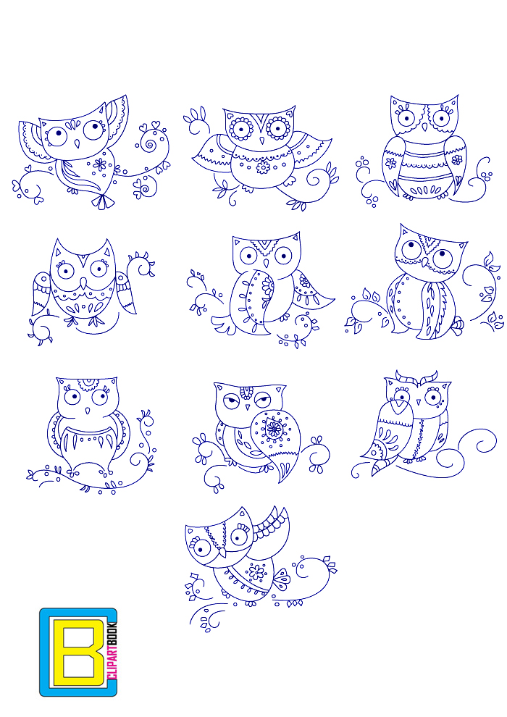

**Reserve Champion**



Division:

Judge:

Horse:

**HomeShow**

**Hoote-NAN-ny**

**2020**

Online Photo Show



**Champion**



Division:

Judge:

Horse:

**HomeShow**

**Hoote-NAN-ny**

**2020**

Online Photo Show



**Overall Reserve Champion**

Division:

Judge:

Horse:

**HomeShow**

**Hoote-NAN-ny**

**2020**

Online Photo Show



**Overall Champion**

Division:

Judge:

Horse:

**HomeShow**

**Hoote-NAN-ny**

**2020**

Online Photo Show



**Reserve Champion**

Section:

Judge:

Horse:

**HomeShow**

**Hoote-NAN-ny**

**2020**

Online Photo Show



**Champion**

Section:

Judge:

Horse:

If you won Champion or Reserve Champion in a SECTION of a division, print the award that says SECTION.

If you won OVERALL Champion or Reserve, print the ribbon that says OVERALL.

If you won Champion or Reserve in a division that has NO sections (ie China, Performance, etc.), print the award that says DIVISION.

You are looking for this information below the star or sun on the ribbon.

Simply print the amount you need, cut them out and store them with your model!

Print on colored paper or color them with colored pencil or whatever you like!